What is a Virtual Environment?
Python's official documentation says:
"A virtual environment is a Python environment such that the Python interpreter, libraries and scripts installed into it are isolated from those installed in other virtual environments, and (by default) any libraries installed in a “system” Python, i.e., one which is installed as part of your operating system"

To use venv in your project, in your terminal, create a new project folder, cd to the project folder in your terminal, and run the following command:
python<version> -m venv <virtual-environment-name>

C:/Users/SaifUllahKhan/AppData/Local/Microsoft/WindowsApps/python3.9.exe -m venv venv
python3.8 -m venv env : - create the virtual env folder with the env

.\venv\Scripts\activate : - Used to activate the virtual env
pip freeze > requirements.txt
pip install -r requirements.txt

Import File
Import <file name > :- when we import the file we the file will automatically run.

Pydantic is the most widely used data validation library for Python.

How to run a file containing Fast api as staring point :-
if __name__ == "__main__":
uvicorn.run("FastApi:app", host="127.0.0.1", port=8000, reload=True)
then just write this in terminal
python.exe .\FastApi.py

fastapi dev <python-file_name> :- its like that fastapi dev .\FastApi.py
The upper link open the simple website and its entry point but if I go with the /doc then i get the swagger view
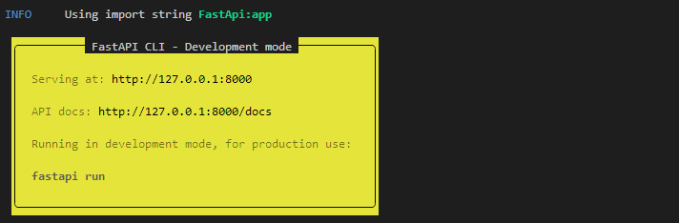

uvicorn FastApi:app –reload :- this command also use to run the command but it will generate only website link not the swagger link but if I want to get I just add
“/doc ” to that link http://127.0.0.1:8000 so the link will be like
http://127.0.0.1:8000/docs

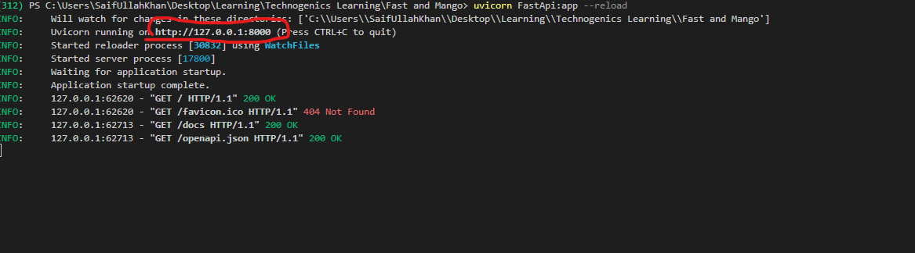

why does the mango find queries return the doc object as dicitionary not as json?
In MongoDB, when you perform queries using methods like find(), the documents retrieved are returned as Python dictionaries, not as JSON. This behavior is due to how MongoDB and the PyMongo driver handle data:

